**MIDDLE EAST TECHNICAL UNIVERSITY**

**Department of Electrical and Electronics Engineering**

**EE564: DESIGN OF ELECTRICAL MACHINES**

**Take Home Exam**

**Student Name:** Elif Topaloğlu - 2443984

**Date:** 22/01/2025

İçindekiler

**Introduction** 3

**1.** **Motor Data** 3

**2.** **Test Data** 5

**3.** **Parameter Calculation Using Test Data** 6

**4.** **Parameter Calculation Using Motor Data** 8

**5.** **Performance** 12

**Conclusion** 16

## 

## **Introduction**

The goal of this exam is to find the parameters o an induction motor given using both test data presented and the motor parameters. Firstly, motor parameters and the test data will be presented. After that, motor parameters will be calculated using both the test data and the motor data presented, and finally, performance of the two methods are compared by calculating the torque, power and the current values.

## **Motor Data**

The motor given to me is a 200 frame 37 KW squirrel cage induction motor. To calculate the motor parameters, one should now more than just the power and the frame of a motor. Thus, the given parameters of the motor are presented below.

Figure 1. Motor data given initially

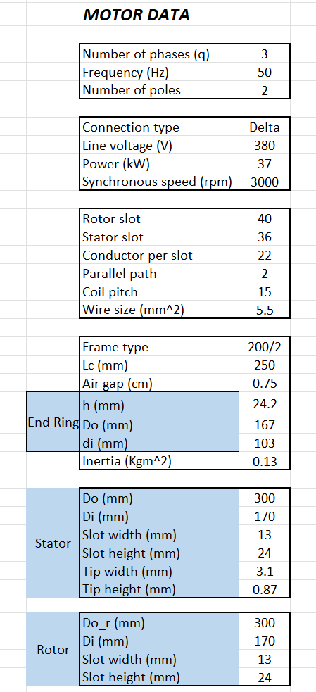

Some of the values given in the figure is directly given by the exam question. Other parameters, especially dimensions of the rotor, stator and the slots are taken from the figure given in the exam sheet as well. Some main dimensions are show in figure below.

diyagram, taslak, çizim, metin içeren bir resim

Açıklama otomatik olarak oluşturuldu

Figure 2. Main dimensions of rotor and the stator

Also, while calculating the parameters, we will need the core loss, DC permeability and BH curves. These curves are extracted from the given plots and plotted using the data points on the graph in MATLAB. The figures are shown below.

metin, diyagram, çizgi, öykü gelişim çizgisi; kumpas; grafiğini çıkarma içeren bir resim

Açıklama otomatik olarak oluşturuldu

Figure 3. DC magnetization and permeability curves

metin, öykü gelişim çizgisi; kumpas; grafiğini çıkarma, çizgi, diyagram içeren bir resim

Açıklama otomatik olarak oluşturuldu

Figure 4. Core loss curve

## **Test Data**

Since the parameters will be calculated using two methods namely analytical and the test, one should know the test data namely open circuit test and short circuit (locked rotor) test. Open circuit and short circuit test setups are given in figure below. Also, the test values are given below.

a) b)

Figure 5. a) Open circuit test b) Short circuit test schematics

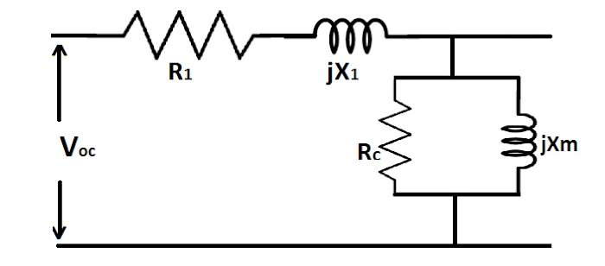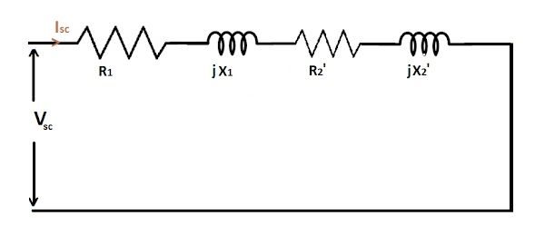

Figure 6. Test data initially given

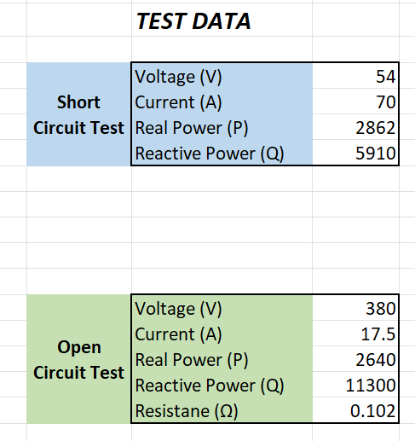

## **Parameter Calculation Using Test Data**

Parameters of the induction motor namely phase resistances (R1 and R2), leakage reactances (X1 and X2), magnetizing reactance (Xm) and core loss resistance (Rc) can be calculated from the results gathered from open circuit and short circuit test experiments. It is said by the instructor that the parameters should be calculated in a way that it is calculated in the book called “Electric Machinery by A.E. Fitzgerald”. The procedures and the formulas to calculate the parameters will be given in this section.

To calculate the phase resistance R1, the measured resistance value in the open circuit test should be used. Since the motor in this project is delta connected, the resistance can be calculated as follows:

Now, core losses should be calculated in order to find the core loss resistance. According to the book, core loss can be calculated as below. Note that if the rotational power is not given, take it as 1% of the rated power.

Core loss resistance can be calculated as follows:

After this part, it is time for the calculation of leakage reactance. Firstly, no load reactance can be calculated as below:

Also, blocked rotor reactance and the blocked rotor resistance values should be obtained. To obtain the blocked rotor reactance value, one should know the test frequency. In general, as it is stated in the book, test frequency is equal to rated frequency for the motors with HP smaller than 25. For the motors with higher HP values, test frequency is approximately equal to 25% of the rated frequency. Thus, the frequency ratio in this calculation is 4.

Blocked rotor resistance can be found as below:

Now, leakage reactance of primary and the secondary referred values can be calculated. In general, for induction motors, X1 and X2 values are very close and assumed to be equal for simple calculations. Any of the reactance values can be found by solving the second order equation found by equation the X1 and X2 values.

Magnetizing reactance now can be found as the leakage reactance is found.

Finally, secondary side referred phase resistance (R2) can be found as given below:

The R1 and R2 resistances should be comparable and do not differ significantly. When the values found are considered they have very small difference between them which shows that the calculations done are not so faulty. In the following section, same parameters will be calculated using the motor data.

## **Parameter Calculation Using Motor Data**

Parameters of the induction motor will be calculated now from the motor data given in section 1. The procedures and the formulas to calculate the parameters will be given in this section.

Firstly, as in the case for the case in the test data calculation, we will start with the phase resistance calculation for the primary. However, some parameters should be calculated in first. Turns per phase will be calculated as below:

Next, pole pitch can be calculated as below:

To calculate the phase resistance, length of the phase windings should be known. As it is hard to calculate the exact length of a turn, MLT term is generated which is the mean length per turn to calculate the overall length easily. MLT can be calculated as below. Coil pitch and the gap diameter is given in the question. K is a constant in general given by the manufacturer. As it is not given in the question, it is taken as 1 which is not an absurd assumption considering the other motor dimensions.

Finally, phase resistance is found below. The value is very close to the calculated test data value.

Next step is the calculation of the referred stator resistance. For starters, winding factor (kw) is selected approximately as 0.955. Bar current can be calculated as below:

To calculate the rotor referred resistance, we should find the bar and end ring resistance. To calculate these, some parameters should be decided.

Bar length can be calculated using some parameters given in the question. Exact values of the dimensions can be found in the excel sheet.

End ring length, end ring and bar area can be found using the formula below. These calculations will be used while calculating the bar and end ring resistances.

Finally, bar resistance and end ring resistance can be calculated using the calculated values. And after that, rotor resistance can be calculated.

The value found for the rotor referred resistance is slightly more than the test data value. The reason can be due to measurement errors during the test procedures or taking some lengths on the motor approximately. Due to these reasons, calculated parameters can be different slightly.

Now we should continue to calculate the leakage reactance. Note that there are various kinds of leakage values for the induction motor such as zigzag leakage, overhang leakage, etc. Thus, with the given parameters only, it is hard to calculate all the leakage values analytically. Thus, for simplicity, this project will calculate only the slot leakage reactance and multiply it with a constant to estimate the actual leakage reactance since only calculating slot leakage reactance will give a smaller leakage reactance than expected. As in the case of the test data calculations, X1 and X2 reactance can be assumed as equal.

For slot leakage reactance, first, we should calculate permanence coefficient. For this type of slot type, calculation can be found as below:

As the leakage reactance does not contain all types of reactances, it has a smaller value than the test data. However, it is still very similar to the calculated value in the test data section.

Next step is to calculate the core loss resistance. There exists no easy way of calculating the core resistance but there still exists some simple ways to calculate the core loss. There are some design sheets which gives the core loss ratio. In figure 4, one can find the core loss ratio for frequency and induction. The frequency is given as 50 Hz and the approximate induction can be selected as 1 T. Then the core loss ratio is found below:

Since the core loss ratio is given as watts per kilogram, we need the mass of the motor. For industrial 200 frame motors, an approximate mass is found to be 270 kg. Then, core loss can be calculated as follows:

Finally, core loss resistance can be calculated as below:

Since the core loss resistance is found very close to the test data value, we can say that the mass assumption is good enough.

As a final calculation, magnetizing reactance should be calculated. To calculate the magnetizing reactance, we need to know the magnetizing current. Calculating the magnetizing current is not easy again, but can be approximated by the formula below:

This is higher compared to the test data value. The reason is that the calculation of the magnetizing current is not exact but approximate.

Finally, in the last section, performance of the calculations will be compared by calculating current, torque and power values for two cases.

## **Performance**

Lastly, in this report, the performance of the motor will be shown by comparing the two methods. Some parameters such as input current, torque and power will be derived and corresponding plots will be drawn.

Firstly, as the current versus speed graph will be drawn. As the current is related to the speed and the slip, they are found and written to the excel sheet. For the zero speed, slip is maximum, which is equal to 1. For the synchronous speed, the slip is equal to its minimum value zero. Speed values are generated with 50 rpm step size and the slip step is arranged accordingly. Then, the current can be calculated by the following formula:

As the first step, the current plot will be obtained using the parameters calculated with the test data. Thus, resistances and the reactance values are taken from the parameters calculated by the test data section of the excel sheet. Corresponding current versus speed plot is presented below.

Figure 7. Current versus speed for test data

The input current is at its maximum value when the speed is minimum and decreases while the speed increases as expected. Maximum current value is around 75A.

Torque versus speed plot is also an important parameter for an induction motor. It can be calculated now as the current values are known. The formula for calculating the torque is presented below.

Torque speed plot is also drawn using the test data obtained parameters and presented below.

Figure 8. Torque speed plot for test data

Torque versus speed plot is also similar to a general type of induction motor data. As can be seen from the plot, maximum torque value is approximately equal to 132 Nm.

Finally, power can be easily calculated with known torque and speed values. As the relation between torque and the speed is linear, the trend of the plot for the power versus speed will be similar to the torque versus speed graph. The formula for the power is given below. Also, power versus speed plot is given below.

Figure 9. Power vs speed plot for test data

The plot for the power versus speed is similar to the torque versus speed plot as expected and the maximum value for the power is approximately equal to 37 kW as it is given in the ratings of this motor.

Same procedures are done for the motor data derived parameters. All the plots are obtained again for the motor parameters and given below.

Figure 10. Input current vs speed plot for motor data

The plot is similar to the test data plot with small deviations. Starting current for this plot is approximately equal to 78A which is really close to test data value but slightly higher. The reason stems from the small deviation in the phase resistance and leakage reactance values.

The plot is again very similar to the test data plot with small deviations. Maximum torque for this plot is approximately equal to 139 Nm which is really close to test data value but again higher. The reason for this is the deviation of R2 resistance also.

Finally, the power speed plot is similar to the expected values. Maximum power is approximately 38 kW, which is slightly higher than the first calculations but still close to the ratings.

When the two methods are observed, it can be seen that the test data results seem more accurate. The deviation between the two methods can be seen by comparing them and gathering the errors between two calculation methods. Error between two values can be found as below. All the errors in these calculations are shown below. The calculations are done for the peak values only for simplicity.

All the errors are smaller than 5%, which shows that the calculations are pretty accurate with high performance.

## **Conclusion**

In this report, the parameters of a 37-kW squirrel cage induction motor were calculated using two methods: experimental test data (open circuit and short circuit tests) and motor design data. The calculated parameters include phase resistances, leakage reactances, magnetizing reactance, and core loss resistance. The results of the two methods were compared by plotting current, torque, and power versus speed and evaluating the motor's performance.

The results showed that both methods produced similar parameters and performance plots, with small deviations. The test data method provided slightly more accurate results, as expected, due to its reliance on measured values rather than approximations. The error rates between the two methods were calculated for current, torque, and power, all of which were below 5%. This indicates that both methods are highly reliable for analyzing induction motor performance.

Overall, this project demonstrates the accuracy of both test data and design data approaches for parameter estimation and highlights the importance of careful approximations in motor design calculations. The results confirm the motor's performance aligns well with its specifications, proving the reliability of the analysis.